NAGVA Board Call
Meeting Minutes: 04/18/2018

- Roll Call – Jen C, Andrew C, Lew S, Mark E, Rich S, Jason F, Eric N, Mark D, Brian S, Scott K, Brian C
- Officer/Department Reports
  - President
  - Vice President
    - NAGVA Hall of Fame: We have received several great nominations, and our committee will meet next week to review and discuss the incoming/first HOF class.
    - We will also review the experience for each of them to ensure it is aligned with the honor. Our deadline to complete the selection is before 5/1.
  - Secretary
    - NAGVA Serves – Avenues of Youth – 4-6 hour project
    - Send travel information for Championships to Lew if you haven’t already
    - Letters of intent due April 25th
  - Treasurer
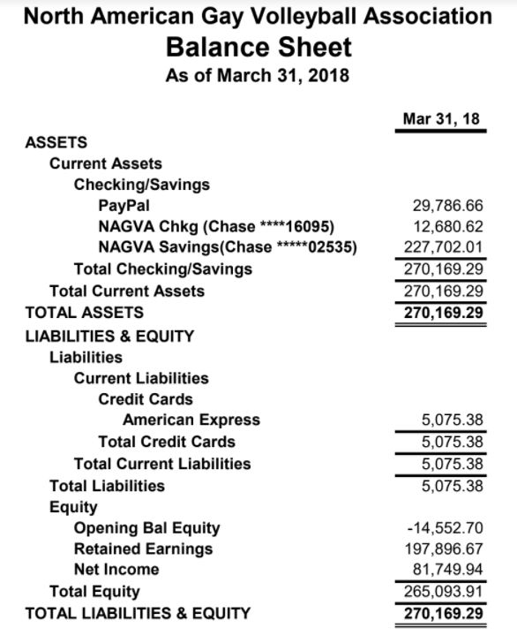
  - Registrar
    - Database issues
    - Jason F suggested a phone call with Marshall
  - Technology
  - Eligibility
    - March Report
      - Medical Re-Rate: 16 received; 12 granted, 4 denied
      - 3 Year Inactive Re-Rate: 15 received; 14 granted, 1 denied
      - Re-Rate Protest/Appeal: 3 received, 1 granted, 2 denied
  - Regions
    - # of Tournaments: 6 tournaments (Cincinnati, Vancouver, Houston, NYC, Denver, Champaign)
    - # of Nonrates: 400
    - # of Rerates: 59 (64.4% uprates, 30.5% same, 5.1% downrate)
    - Total # of RCs Utilized: 9 RCs (Houston and NYC - all had multiple RCs) - 4/6 tournaments had RCs out of region.
  - Tournaments
    - Denver tournament had issues – no running water at the facility
    - Player sent an email laying out the issues with the Denver tournament
    - Summer season is under way – San Francisco moved to last weekend of June and Madison tourney moved their weekend away from Chicago – Market Day weekends
    - Insurance Policy – Championships needs it’s own policy – will have it figured out this week
  - Officials
  - Communications
  - Canadian Representative
- MAL Reports
  - Trevor
  - Rich
  - Brian
  - Jimmy
- Championships Update
  - Tournament
    - 75 teams paid
    - Pay deadline – May 1st
    - Facility – only in one hall – 16-19 courts
    - Arrangements for laying and picking up courts have been made
  - Hotel
    - Currently have booked 883 room nights of our 979 commitment - at 90.2% of block. We have 96 available room nights spread through our pattern.
    - If you find anyone who has any challenges booking in the coming weeks, please let me know ASAP. I will watch the pattern to see if we need to ask for any additional nights. This is a great spot to be, as we have eliminated any attrition liability with the hotel.
  - Board Meeting – Wednesday, May 23rd – 9:00 – 4:30pm
  - Local: Looking for a massage therapist
- New Business
  - Bruce Ingersoll Appeal Update
  - Nathan Burge Eligibility Appeal – Unanimous not granting appeal
  - Salt Lake City – proposal for no convention center fee in 2021 – Must make the decision by Dec 31, 2018
  - NAGVA Spirit Award
- Meeting Adjourns

